Web Intern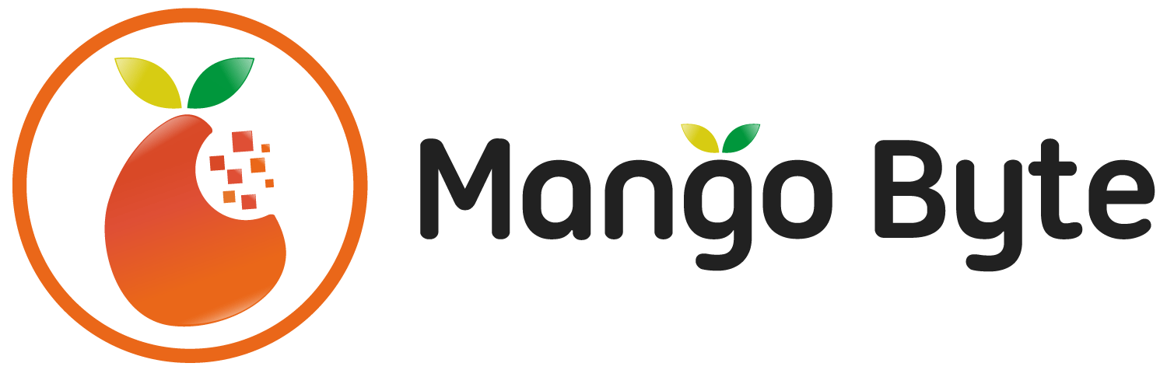

Mango Byte Technology Co., Ltd.

Profile

MANGO BYTE is a web development company based in Phnom Penh, Cambodia, providing high-quality services to international customers. Starting with Cambodian super engineers built by two Japanese engineers and business professionals. We are eager to develop creative, innovative, cutting-edge technology and businesses such as web service and system, mobile (iOS and Android) application, etc.

Our value is always to invest in our growth, challenge, freedom, and Self-management. We always treat each other with respect and dignity. With our growing and expanding operation, currently, we are looking for any engineers and developers interested in the international-standard business are all welcome.

Our first goal is to be an international-level technology company in Asia from Cambodia HQ. We want people who want to be international to join us.

MANGO BYTE offers you a career to work with international clients and a great working environment; it’s not just a job; it’s our passion that inspires your life.

Job Description

- Designs develop and modify software modules based on functional and system requirements, according to code standards and user interface design guidelines

- Performs program maintenance, modifications, and enhancements to existing applications through programming, testing, documenting and training users

- Contribute clean code to ensure a consistently high-quality standard

- Propose and assess solutions to resolve problems, including identifying and evaluating new technologies and third-party components

- Understand and execute the technical concepts and the client requirements to ensure the high-quality technical solution

- Understand and be able to explain the roles and responsibilities within the

and how to work in an Agile environment

- Provide more complicated automated test method and understand the test-driven development concept

- Be able to give accurate rough estimations and point out dependencies between issues

Job Requirement

- Have logical thinking and knowledge of basic mathematical logic

- Knowledge of basic computer science and basic software testing (Whitebox/Blackbox test)

- Can write codes for a few of algorithms

- Knowledge of basic OOP and its essential factors (Not only definition)

- Understand trendy design model patterns such at least MVC as an application of OOP

- Experience of any programming languages such as node.js/Ruby/PHP/Python/C#/JAVA

- Proficiency in HTML5/CSS3/JS

- Experience of implementing Ajax interfaces on the backend

- Understand SQL commands and ORMs

- High understanding of client's requirements for the business domain of the product

- Can properly design DB structures in accordance with client's requirements

- Can review codes for other developers and understand how to write codes readable

- Love to read books

- High level of English communication

Please tell us your knowledge about each topic above in the interview

* Working Style
* Working day and time: Flexible and 15 to 40 hours per week depends on your lifestyle
* Holidays: follow the Cambodian national holidays
* International working style
* Modern working environment
* Remote working environment
* Benefits
* Competitive salary and quarterly incentives
* Innovative and systematic training programs
* English training program
* Accident and health insurance
* Free tea; snacks & coffee (Amazon & monthly free Pizza…etc.)

Training Materials

Every developer at Mango Byte can take services below for free for developing your skills.

1. Udemy for business (https://www.udemy.com)

Can access to paid 2,000+ courses unlimitedly

2. O’Reilly Safari (https://www.safaribooksonline.com)

Can read 40000+ books and watch videos

How to evaluate your performance

We will evaluate every single person of you for each responsibility and goals. We define and set personal goals and responsibilities and we will evaluate your performance with them.

The evaluation should be taken by your productivity and skills first. Then also we evaluate your additional effort and responsibilities when you can be in charge of certain projects, problems, training, and any tasks including learning new technologies, languages, and skills such as clean architecture, realm.js, RxAndroid, etc. Anyone can take any responsibilities and challenges. We will evaluate all and any of your efforts and we’ll support you all the time.

Contact Information

HR Department

[recruit@mango-byte.com](mailto:sales@mango-byte.com)

Mango Byte Technology Co., Ltd.

<http://www.mango-byte.com/>

 Company Address: Building: Aquation - Office Park, #540 Koh Pich St

Sangkat Tonle Basak, Khan Chamkar Mon, Phnom Penh